CS560/CS460 Handout

OpenGL Functions
(From The Red Book “OpenGL Programming Guide Third Edition”)

glMatrixMode(GL_PROJECTION) (page 103-105 of red book)
glMatrixMode(GL_MODELVIEW)

glMatrixMode() is used with the argument GL_PROJECTION. This indicates that the current matrix specifies the projection transformation; the following transformation calls then affect the projection matrix.
glMatrixMode()called with GL_MODELVIEW as the argument. This indicates that succeeding transformations now affect the modelview matrix instead of the projection matrix.

glLoadIdentity() (page 105 of red book)

It has no parameter, use the glLoadIdentity() command to clear the currently modifiable matrix for future transformation commands, since these commands modify the current matrix. Typically, you always call this command before specifying projection or viewing transformations, but you might also call it before specifying a modeling transformation.

glViewport(0, 0, width, height) (page 129-130 of red book)

The arguments to glViewport() describe the origin of the available screen space within the window - (0, 0) in this example - and the width and height of the available screen area, all measured in pixels on the screen. The viewport is the rectangular region of the window where the image is drawn. It is measured in window coordinates, which reflect the position of pixels on the screen relative to the lower left corner of the window.

glTranslate*() and glScale*() (page 110-111 of red book)

These are transformation commands. * indicates 2D or 3D environment and variable type. For example, glTranslatef(10.0, 10.0, 10.0) translate current project 10 pixels along x, y, z axis respectively.

When doing transformation, you must pay attention to the order. Different order will result to totally different results, as shown in this figure. Left image is translation after rotation, while right image rotation after translation:

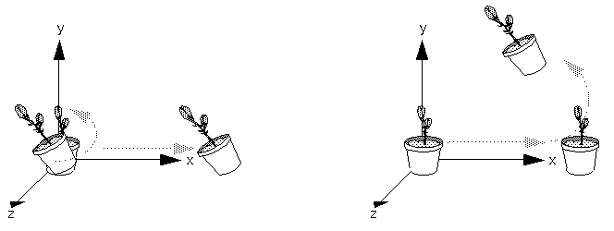

void gluLookAt(GLdouble eyex, GLdouble eyey, GLdouble eyez, GLdouble centerx, GLdouble centery, GLdouble centerz, GLdouble upx, GLdouble upy, GLdouble upz);

(page 119 of red book)

This routine is particularly useful when you want to pan across a landscape, for instance. With a viewing volume that's symmetric in both x and y, the (eyex, eyey, eyez) point specified is always in the center of the image on the screen, so you can use a series of commands to move this point slightly, thereby panning across the scene. (centerx, y z) give the position of the point where you are looking at. (upx, y, z) describes which direction is “up” in this moment.

void gluPerspective(GLdouble fovy, GLdouble aspect, GLdouble zNear, GLdouble zFar) (page 126 of red book)

This function creates a symmetric perspective view for specified objects. Appropriate parameters must be selected to ensure the object can be displayed correctly. The parameters used in this function are show in following figure.
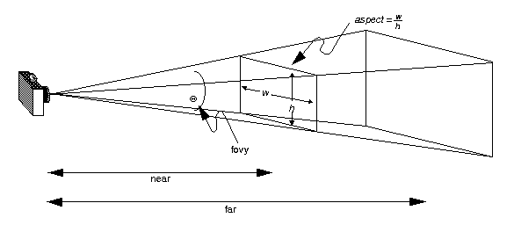

void gluOrtho2D(GLdouble left, GLdouble right, GLdouble bottom, GLdouble top)

(page 127-128 of red book)

This function is used to create an orthogonal view. The objects won’t be displayed smaller while the distance become further, as the way it does in perspective view.
Parameters are shown in following figure.

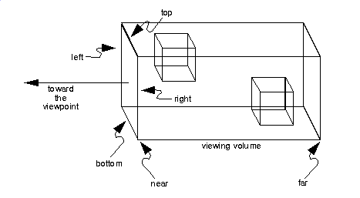
void glPushMatrix(void);

(See details at page 135-138 of red book)
Pushes all matrices in the current stack down one level. The current stack is determined by glMatrixMode(). The topmost matrix is copied, so its contents are duplicated in both the top and second-from-the-top matrix. If too many matrices are pushed, an error is generated.
void glPopMatrix(void);
Pops the top matrix off the stack. What was the second-from-the-top matrix becomes the top matrix. The current stack is determined by glMatrixMode(). The contents of the topmost matrix are destroyed. If the stack contains a single matrix, calling glPopMatrix() generates an error.
All the transformations in OpenGL are stored as matrices, a matrix stack provides an ideal mechanism for doing successive remembering, translating, and throwing away. All the matrix operations that have been described so far deal with the current matrix, or the top matrix on the stack. You can control which matrix is on top with the commands that perform stack operations: glPushMatrix(), which copies the current matrix and adds the copy to the top of the stack, and glPopMatrix(), which discards the top matrix on the stack.

void gluSphere(GLUquadric* quad, GLdouble radius, Glint slices, Glint stacks);

Parameters
quad
Specifies the quadrics object (created with gluNewQuadric).
radius
Specifies the radius of the sphere.
slices
Specifies the number of subdivisions around the z axis (similar to lines of longitude).
stacks
Specifies the number of subdivisions along the z axis (similar to lines of latitude).

Description
gluSphere draws a sphere of the given radius centered around the origin. The sphere is subdivided around the z axis into slices and along the z axis into stacks (similar to lines of longitude and latitude).

void gluCylinder(GLUquadric* quad, GLdouble base, GLdouble top, GLdouble height,, Glint slices, Glint stacks);

Parameters
quad
Specifies the quadrics object (created with gluNewQuadric).
base
Specifies the radius of the cylinder at z = 0.
top
Specifies the radius of the cylinder at z = height.
height
Specifies the height of the cylinder.
slices
Specifies the number of subdivisions around the z axis.
stacks
Specifies the number of subdivisions along the z axis.

Description
gluCylinder draws a cylinder oriented along the z axis. The base of the cylinder is placed at z = 0 and the top at z=height. Like a sphere, a cylinder is subdivided around the z axis into slices and along the z axis into stacks.
Note that if top is set to 0.0, this routine generates a cone.

